Building Simple ReAct Agent from Scratch In Python
Step-by-Step Guide to Building LLM Agents with LangGraph

In the second article of the Building LLM Agents with LangGraph Series, we will build a simple ReAct (Reasoning and Action) Agent from scratch using Python.
This article starts with a brief introduction to ReAct agents and their main components and how they work. Then we will define a simple agent class and define the system prompt and the helper functions.
Finally, we will test the agent with some examples, and then we will automate the agent call with a simple Python script.
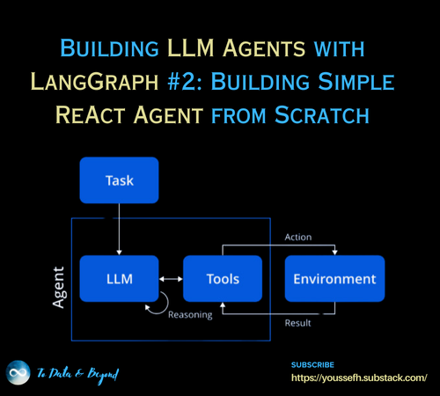
This article is the Second Article in the ongoing series of Building LLM Agents with LangGraph:
- Introduction to Agents & LangGraph (Published!)
- Building Simple ReAct Agent from Scratch (You are here!)
- Main Building Units of LangGraph (Coming Soon!)
- Agentic Search Tools in LangGraph (Coming Soon!)
- Persistence and Streaming in LangGraph (Coming Soon!)
- Human in the Loop in LLM Agents (Coming Soon!)
- Putting it All Together! Building Essay Writer Agent (Coming Soon!)
This series is designed to take readers from foundational knowledge to advanced practices in building LLM agents with LangGraph.
Each article delves into essential components, such as constructing simple ReAct agents from scratch, leveraging LangGraph’s building units, utilizing agentic search tools, implementing persistence and streaming capabilities, integrating human-in-the-loop interactions, and culminating in the creation of a fully functional essay-writing agent.
By the end of this series, you will have a comprehensive understanding of LangGraph, practical skills to design and deploy LLM agents, and the confidence to build customized AI-driven workflows tailored to diverse applications.
Table of Contents:
- Introduction to ReAct Agents
- Build ReAct Agent
- Test Agent with Different Examples
- Automate the Agent Call
Most insights I share in Medium have previously been shared in my weekly newsletter, To Data & Beyond.
If you want to be up-to-date with the frenetic world of AI while also feeling inspired to take action or, at the very least, to be well-prepared for the future ahead of us, this is for you.
🏝Subscribe below🏝 to become an AI leader among your peers and receive content not present in any other platform, including Medium:

To Data & Beyond | Youssef Hosni | Substack
Data Science, Machine Learning, AI, and what is beyond them. Click to read To Data & Beyond, by Youssef Hosni, a…
youssefh.substack.com

1. Introduction to ReAct Agents
The ReACT (Reasoning and Action) agent model is a framework designed to integrate the reasoning capabilities of large language models (LLMs) with the ability to take actionable steps, creating a more sophisticated system that can understand and process information, evaluate situations, take appropriate actions, communicate responses, and track ongoing situations.
It was first introduced in the paper “ReAct: Synergizing Reasoning and Acting in Language Models” in October 2022, and revised in March 2023. The framework was developed to synergize reasoning and action-taking in language models, making them more capable, versatile, and interpretable.
Press enter or click to view image in full size
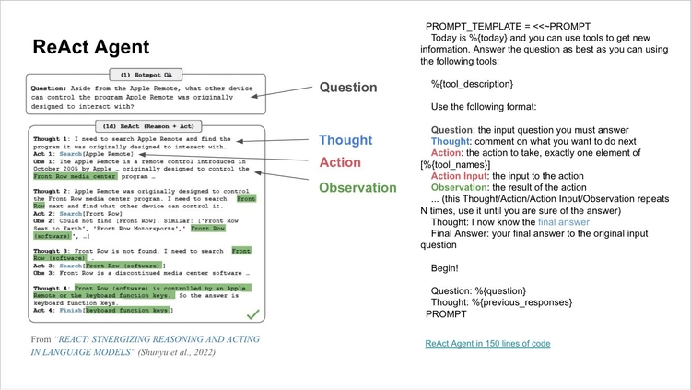
ReAct enables agents to alternate between generating thoughts and task-specific actions dynamically by interleaving reasoning and acting.
The LLM follows a step-by-step problem-solving approach, utilizing various tools or APIs to gather information and perform tasks. ReAct is adaptable to different domains and provides transparency in decision-making, allowing human oversight.
Initially, ReACT showed improved performance over other prompting techniques, particularly in complex, multi-step tasks, but was largely superseded in late 2023 by native function calling techniques supported by OpenAI, Anthropic, Mistral, and Google models. We recommend using function or tool calls instead of ReACT for most production-ready features.
The model uses a specific prompt structure to guide reasoning and action generation and has been implemented in various AI frameworks like LlamaIndex and LangChain, making it accessible for developers to create more capable, reasoning-driven AI applications.
2. Build ReAct Agent
Before we build the ReAct agent we will start by importing some helper functions and packages we will use and also define the LLM client, which will be openai LLM in this case.
import openai
import re
import httpx
import os
from dotenv import load_dotenv
_ = load_dotenv()
from openai import OpenAI
client = OpenAI()
We will next define an Agent class. The Agent class is a simple implementation of a conversational AI agent that maintains a dialogue history and interacts with a language model.
When initialized, it can optionally take a system message that sets the context for the conversation, which is stored along with the conversation history in a messages list.
Calling the agent with a user message adds that message to the history, sends the complete conversation to the language model via the execute method, and retrieves a response. The response is then added to the conversation history as an assistant message and returned to the user. This design allows the agent to manage a continuous, context-aware dialogue by maintaining a full record of the interaction.
class Agent:
def __init__(self, system=""):
self.system = system
self.messages = []
if self.system:
self.messages.append({"role": "system", "content": system})
def __call__(self, message):
self.messages.append({"role": "user", "content": message})
result = self.execute()
self.messages.append({"role": "assistant", "content": result})
return result
def execute(self):
completion = client.chat.completions.create(
model="gpt-4o",
temperature=0,
messages=self.messages)
return completion.choices[0].message.content
Next, we will define the system prompt for our ReAct agent. We start by defining the ReAct agent's main components, and then we ask the model to operate in a cycle of thought, action, PAUSE, and observation.
Then we define the available actions to the agent. Since we are just building a demo application we will use the agent to estimate the temperature in a given city in Celsius. We define the following actions:
- get_current_weather: Fetches the current weather for the specified location
- get_forecast: Provides a weather forecast for the given location and time range
- convert_temperature: Converts a temperature from Fahrenheit to Celsius or vice versa
After defining the system prompt we will give it a shot example to be able to follow it and act as expected.
prompt = """
You operate in a cycle of Thought, Action, PAUSE, and Observation.
At the end of the loop, you provide an Answer.
Use Thought to reason about the information needed to answer the question you were asked.
Use Action to perform one of the available actions, then return PAUSE.
Observation will be the result of performing those actions.
Your available actions are:
get_current_weather:
e.g., get_current_weather: New York
Fetches the current weather for the specified location.
get_forecast:
e.g., get_forecast: San Francisco, 3 days
Provides a weather forecast for the given location and time range.
convert_temperature:
e.g., convert_temperature: 75 F to C
Converts a temperature from Fahrenheit to Celsius or vice versa.
Example session:
Question: What’s the current temperature in Paris in Celsius?
Thought: I need to get the current temperature in Paris and convert it to Celsius.
Action: get_current_weather: Paris
PAUSE
You will then be called again with this:
Observation: The current temperature in Paris is 77°F.
You continue:
Thought: I should convert 77°F to Celsius.
Action: convert_temperature: 77 F to C
PAUSE
You will then be called again with this:
Observation: 77°F is approximately 25°C.
You finally output:
Answer: The current temperature in Paris is 25°C.""".strip()
Then we will define the action functions described above so the LLM can use them to delegate the tasks.
def get_current_weather(location):
# Placeholder implementation for fetching weather.
return f"The current temperature in {location} is 32\u00b0F."
def get_forecast(location, days):
# Placeholder implementation for fetching weather forecast.
return f"The weather forecast for {location} over the next {days} days is sunny with mild temperatures."
def convert_temperature(conversion):
try:
value, unit_from, _, unit_to = conversion.split()
value = float(value)
if unit_from.upper() == "F" and unit_to.upper() == "C":
converted = (value - 32) * 5 / 9
return f"{value}\u00b0F is approximately {converted:.1f}\u00b0C."
elif unit_from.upper() == "C" and unit_to.upper() == "F":
converted = (value * 9 / 5) + 32
return f"{value}\u00b0C is approximately {converted:.1f}\u00b0F."
else:
return "Invalid temperature conversion. Use 'F to C' or 'C to F'."
except Exception as e:
return f"Error in temperature conversion: {e}"
known_actions = {
"get_current_weather": get_current_weather,
"get_forecast": get_forecast,
"convert_temperature": convert_temperature
}
Now let's try asking the agent What is the temperature in Helsinki? and observe the thoughts and actions in every step.
abot = Agent(prompt)
result = abot("What is the temperature in Helsinki?")
print(result)
Thought: I need to get the current temperature in Helsinki.
Action: get_current_weather: Helsinki
PAUSE
We can see that the thought is I need to get the current temperature in Helsinki and the required action is to use the get_current_weather and the input to it is Helsinki which is the city we want to know its current temperature.
result = get_current_weather("Helsinki")
result
‘The current temperature in Helsinki is 32°F.’
Next, we apply the forecast function and define the duration to forecast to be one day.
result = get_forecast("Helsinki", 1)
result
‘’The weather forecast for Helsinki over the next 1 days is sunny with mild temperatures.’
Finally, we get the final observation of the agent
next_prompt = "Observation: {}".format(result)
abot(next_prompt)
‘Answer: The weather in Helsinki is 0 C \nPAUSE’
Finally, we can get the full summary of the whole conversation with the agent.
abot.messages
[{‘role’: ‘system’,
‘content’: “You operate in a cycle of Thought, Action, PAUSE, and Observation. \nAt the end of the loop, you provide an Answer. \n\nUse Thought to reason about the information needed to answer the question you were asked. \nUse Action to perform one of the available actions, then return PAUSE. \nObservation will be the result of performing those actions. \n\nYour available actions are: \n\nget_current_weather: \ne.g., get_current_weather: New York \nFetches the current weather for the specified location. \n\nget_forecast: \ne.g., get_forecast: San Francisco, 3 days \nProvides a weather forecast for the given location and time range. \n\nconvert_temperature: \ne.g., convert_temperature: 75 F to C \nConverts a temperature from Fahrenheit to Celsius or vice versa. \n\nExample session: \n\nQuestion: What’s the current temperature in Paris in Celsius? \nThought: I need to get the current temperature in Paris and convert it to Celsius. \nAction: get_current_weather: Paris \nPAUSE \n\nYou will then be called again with this: \n\nObservation: The current temperature in Paris is 77°F. \n\nYou continue: \n\nThought: I should convert 77°F to Celsius. \nAction: convert_temperature: 77 F to C \nPAUSE \n\nYou will then be called again with this: \n\nObservation: 77°F is approximately 25°C. \n\nYou finally output: \n\nAnswer: The current temperature in Paris is 25°C.”},
{‘role’: ‘user’, ‘content’: ‘What is the temperature in Helsinki?’},
{‘role’: ‘assistant’,
‘content’: ‘Thought: I need to get the current temperature in Helsinki. \nAction: get_current_weather: Helsinki \nPAUSE’},
{‘role’: ‘user’,
‘content’: ‘Observation: The weather forecast for Helsinki over the next 1 days is sunny with mild temperatures.’},
{‘role’: ‘assistant’,
‘content’: ‘Thought: It seems there was a misunderstanding. I need the current temperature, not the forecast. I will try to get the current temperature in Helsinki again. \nAction: get_current_weather: Helsinki \nPAUSE’},
{‘role’: ‘assistant’,
‘content’: ‘Thought: The weather in Helsinki is 0 C \nPAUSE’}]
4. Automate the Agent Call
In the previous step, we moved from one step to another manually. This is for only educational purposes. In this step, we will automate the three steps of the ReAct agent.
action_re = re.compile('^Action: (\w+): (.*)$') # python regular expression to selection action
def query(question, max_turns=5):
i = 0
bot = Agent(prompt)
next_prompt = question
while i < max_turns:
i += 1
result = bot(next_prompt)
print(result)
actions = [
action_re.match(a)
for a in result.split('\n')
if action_re.match(a)
]
if actions:
# There is an action to run
action, action_input = actions[0].groups()
if action not in known_actions:
raise Exception("Unknown action: {}: {}".format(action, action_input))
print(" -- running {} {}".format(action, action_input))
observation = known_actions[action](action_input)
print("Observation:", observation)
next_prompt = "Observation: {}".format(observation)
else:
return
Thought: I need to get the current temperature in Helsinki.
Action: get_current_weather: Helsinki
PAUSE
— running get_current_weather Helsinki
Observation: The current temperature in Helsinki is 32°F.
Thought: I should convert 32°F to Celsius to provide the temperature in a more commonly used unit in Helsinki.
Action: convert_temperature: 32 F to C
PAUSE
— running convert_temperature 32F to C
Observation: 32.0°F is approximately 0°C.
Answer: The current temperature in Helsinki is approximately 0°C.

